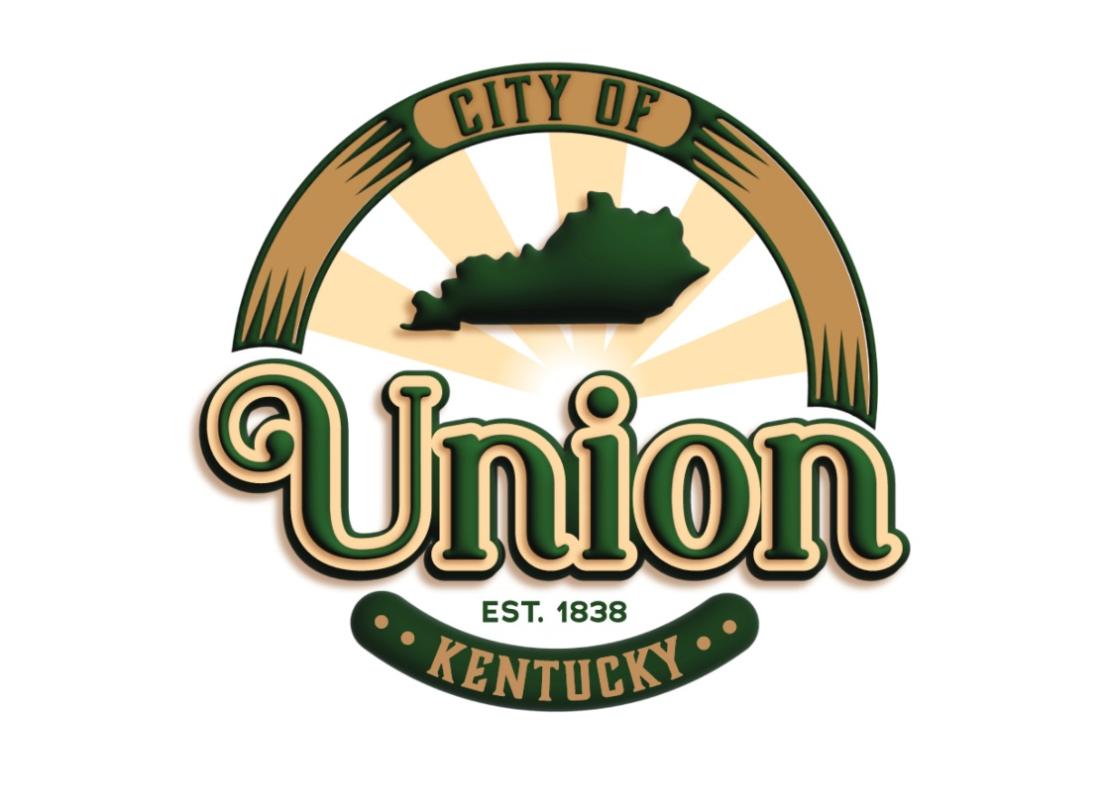
Business
Packet

NEW BUSINESS WELCOME PACKET

The City of Union is excited to welcome you as a business owner. Sitting at the crossroads between the past and future, Union is dedicated to ensuring our current business community grows with us. The Economic Development Committee (EDC), comprised of four community members, one Commissioner, and City staff, advises the City of Union the full range of economic issues and policies that result in resourced solutions consistent with the City’s value statements. The EDC focuses on business recruitment, retention, and expansion while honoring its commitment to balance development and quality of life.

The City of Union continues to experience an extremely high growth rate for single family housing developments. In 1970, the population was 233 people, by year 2000 it reached 2,893, then 5,379 in 2010, and in 2021, there are 7,416 residents in the City of Union. Since the early 1980’s, the thrust of the community and its leaders has been to facilitate and foster the prosperity of business in Union, attract upscale housing development, and provide its citizens with a city that supports them and makes them feel welcome. As a result, the City of Union has grown from the smallest into the second-largest city in Boone County in less than twenty years, remaining remarkably free of the “Urban Sprawl” so prevalent in the country today.

At the dawn of the new millennium, the City of Union undertook the task of reinventing itself for the future of its citizens. In a joint effort involving the State of Kentucky, Boone County, Boone County Planning Commission, and its residents, the City of Union developed a long-range Town Plan to support sustainable growth for future generations.
The Vision of the Economic Development Committee is to explore sustainable opportunities and resources to attract businesses to the City of Union and help them thrive within the community. In this packet you will find contact information, available services, upcoming events, and resources for business owners.

Welcome to the City of Union!

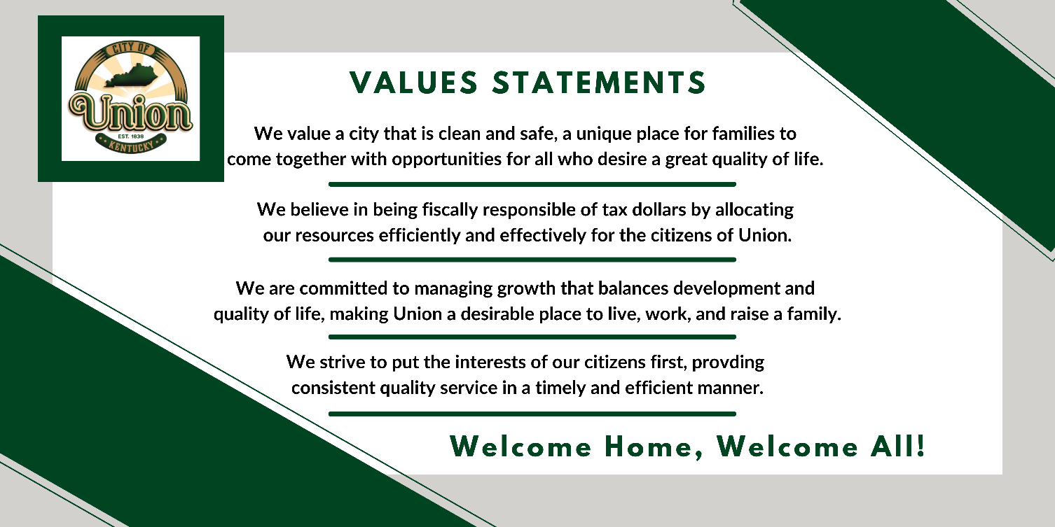

City Commission
City Administration

Mayor: Larry Solomon; mayorlarry@cityofunionky.org

Commissioner: John Mefford; jmefford@cityofunionky.org

Commissioner: Jeremy Ramage; jramage@cityofunionky.org

Commissioner: Brian Garner; bgarner@cityofunionky.org

Commissioner: Doug Bine; dbine@cityofunionky.org

City Administrator: Amy Safran; amys@cityofunionky.org

Public Works Director: Paul Kremer
pkremer@cityofunionky.org

Communications Coordinator:
Jaime Lyons; jlyons@cityofunionky.org

City Clerk: Tammy Wilhoite;
twilhoite@cityofunionky.org

City Treasurer: Christy Everman; frontdesk@cityofunionky.org

City Attorney: Greg Voss; gvoss@vosslaw.net

City Engineer: Barry Burke; burkebarry@msn.com

Regular Commission meetings are held on the 1st Monday of every month at 6:00PM in the Union City Building unless otherwise posted.

Resources

Utility Information

Telephone/Internet service: Altafiber 513-599-8823 or Spectrum 833-272-6789
Water Service: Boone County Water District at 859-586-6155
Sewer Service: Sanitation District #1 (SD1) at 859-578-7450
Electrical Service: Duke Power 513-421-9500 or 800-544-6155
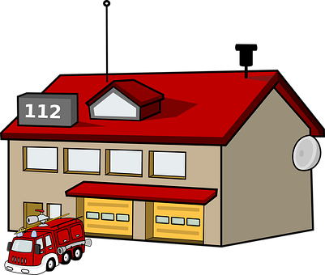
Garbage/Recycling: Rumpke 513-742-2900

Local Assistance

Union Post Office:
859-384-3715
Union Fire Department/EMS:
859-384-3342
Boone County Sheriff’s Department:
859-334-2175
Boone County Building Permits:
859-334-2218
Boone County Planning Commission:
859-334-2196 (Development & Zoning)

Business Resources

NKY Chamber of Commerce: www.NKYChamber.com
NKY Tri-County Economic Development Corporation (Tri-ED): https://northernkentuckyusa.com/
Kentucky Career Center: https://kcc.ky.gov/Pages/default.aspx
Kentucky Small Business Development Center: https://kentuckysbdc.com/covington/
The Kentucky Small Business Tax Credit: https://ced.ky.gov/Entrepreneurship/KSBTC
Kentucky Business Incentives: https://ced.ky.gov/Locating_Expanding/kybizince
Kentucky Workforce Innovation Board: https://kwib.ky.gov/Pages/index.aspx
Northern Kentucky Community Action Alliance: https://www.nkcac.org/

Social Media
Twitter: Instagram:
https://twitter.com/CityofUnionKy https://www.instagram.com/cityofunionky
Facebook: Youtube:
https://www.facebook.com/cityofunionkentucky @cityofunionky5003

Newsletter
Boone County Newsletter:
https://app.cerkl.com/org/profile.php?org=Your-Boone-County#.YRKY5spKiUk

City of Union Demographics

A Family Community
The attractiveness of Union as a place to live and raise a family is evident in the dramatic increase in population over the past 4 decades. In 1970, the population of Union was a mere 233 people. By the year 2000, the population soared to 2893, and then climbed to 5,379 in 2010.

Population
The 2020 US Census numbers reflect a population of 7,416 residing in 1,929 housing units.
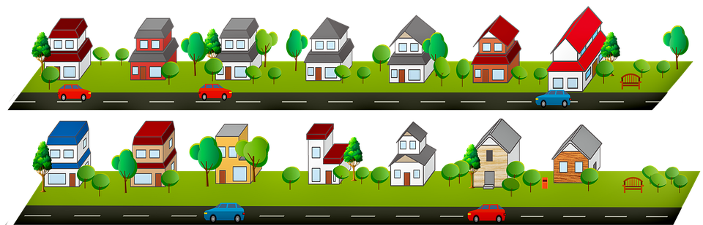
*based on 2020 census

Property
- Median Home Value: $263,200
- Owner-occupied housing unit rate: 93.6%
- Persons per household: 3.06

Income and Education
- Median Household Income: $125,051
- High School Graduate or higher: 97.3%
- Bachelor’s degree or higher: 52.1%
The City of Union is rated “#1 in best places to live in Boone County” (www.niche.com). Union offers a low cost of living with a high quality of family-oriented lifestyle. A 2020 market analysis showed that Union appeals to upscale, professional families with kids, as well as wealthy, empty nesters, 55 and older, embarking on retirement.
_____________________________________________
City Events

Spring: Easter Egg Hunt
Summer: Union Celebrates America
Fall: Bourbon in the Bluegrass
Winter: Breakfast with Santa

Sponsorship opportunities are available contact jlyons@cityofunionky.org

Ribbon Cuttings: Official ceremony is offered to new business owners in the City of Union.

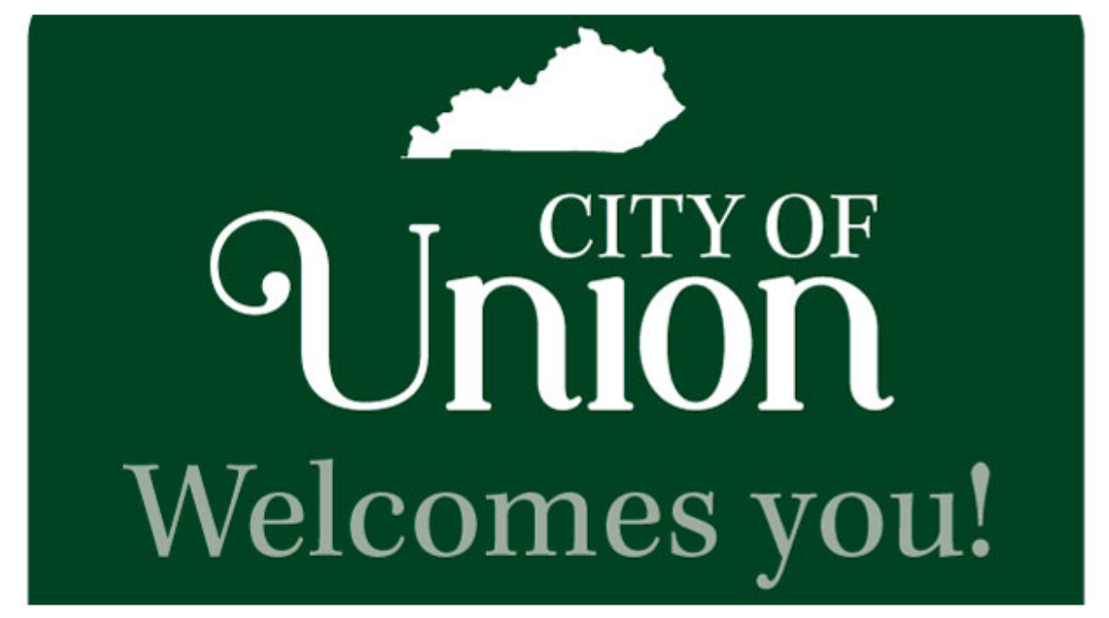

City Building
1843 Bristow Dr.
Union, KY 41091
Phone: 859-384-1511
Hours: Monday-Friday from 10AM-4PM
*Closed on State and Federal holidays

www.cityofunionky.org

