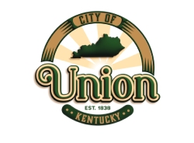

BOURBON IN THE BLUEGRASS

The City of Union, KY proudly presents the 2nd annual Bourbon in the Bluegrass event taking place on **Saturday, October 7, 2023 from 3:00PM – 7:00PM at Farm Haven**. The inaugural event which took place on October 22, 2022 was a huge success bringing in approximately 2,500 attendees. Every participating vendor has asked to return in 2023.

Bourbon in the Bluegrass is a free event featuring Kentucky distillers, microbrewery, winery, food trucks, live bluegrass bands, and hayrides. Farm Haven, a privately owned property in Boone County offering a countryside setting, is the perfect venue for this hometown event.

We invite you to participate in the 2023 Bourbon in the Bluegrass by selling and serving your product(s). We encourage you to include any marketing materials, displays, and merch for sale as you wish. Per KY ABC, KY distillers, microbreweries, and small batch wineries are permitted to sell product at events/festivals under their mobile liquor license. The City of Union will hold a one-day Special Event Permit.

We greatly appreciate your consideration to participate on October 7, 2023. The first event reached over 75,000 viewers on Facebook alone. Additional promotions included online, as well as printed publications. In addition to in-person sales and brand recognition, you are sure to benefit significantly from our event marketing efforts.

Please contact Jaime Lyons at [jlyons@cityofunionky.org](mailto:jlyons@cityofunionky.org) or 859-384-1511 with any questions.

Sincerely,

City of Union Communications Committee

The City of Union

1843 Bristow Drive

Union, KY 41091

[www.cityofunionky.org](http://www.cityofunionky.org)

**Farm Haven (located at 10259 Tadpole Lane, Union, KY 41091)**

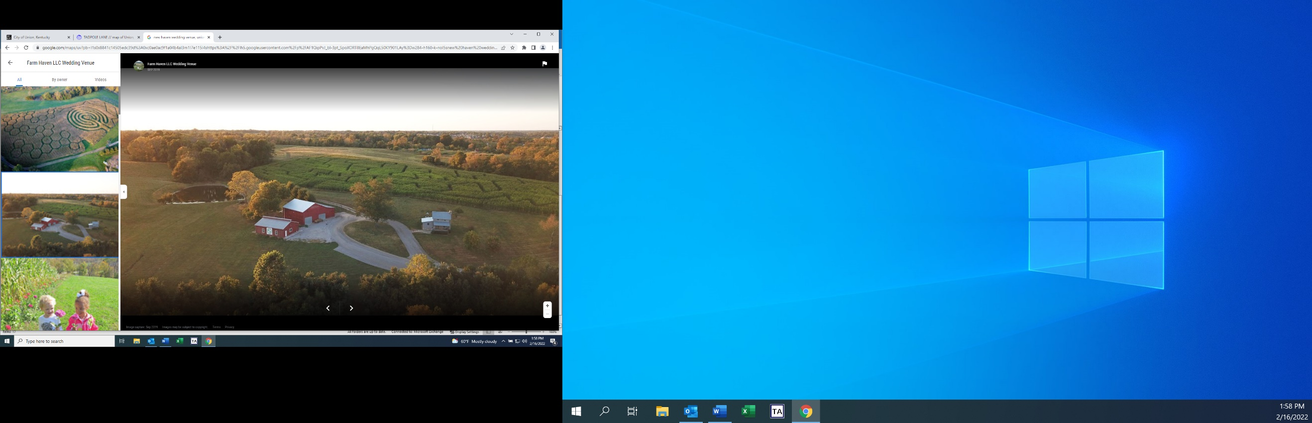**Bourbon in the Bluegrass Venue**